GUIDE TO A SUCCESSFUL ONLINE
PRE-REGISTRATION AT THE UNIVERSITY OF VIENNA
(FOR ERASMUS INTERNATIONAL MOBILITY STUDENTS)
Link to the pre-registration:
http://preregistration.univie.ac.at/
Please note: If you have difficulties in entering some of your data correctly, please complete the pre-registration by selecting any choice provided and send a message including the wrong entry to the following e-mail address:
erasmus.international@univie.ac.at
The data can later be changed manually by us.
In case of problems when clicking on an option, please try again.
Most failure notices appear due to temporary problems.
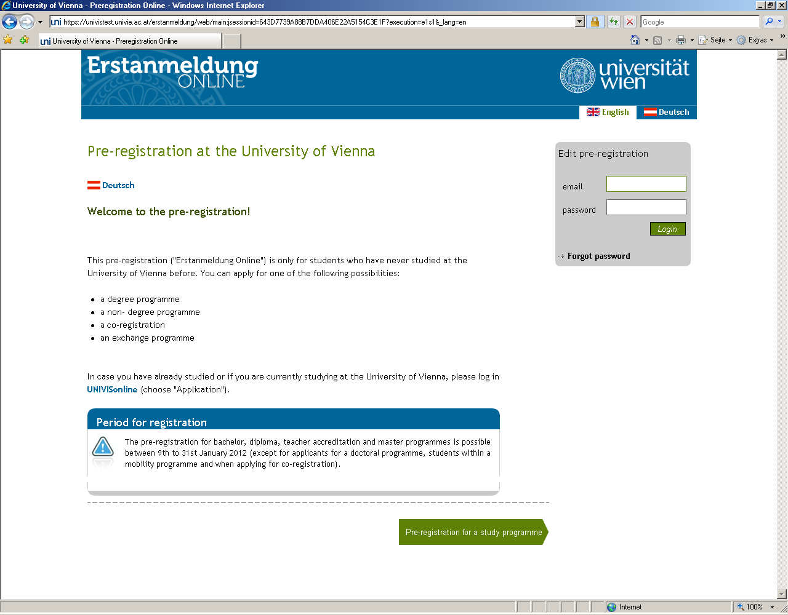
Please click here to start the pre-registration. As an exchange student you can complete the online pre-registration all year round.

Please state your e-mail address here. If you are using an address different from the one you received our information e-mail after your nomination to, please let us know (erasmus.international@univie.ac.at), so that we can prepare your enrolment successfully.
Please memorise your password (min. 5 characters), as you will need it later for activating your u:net account.

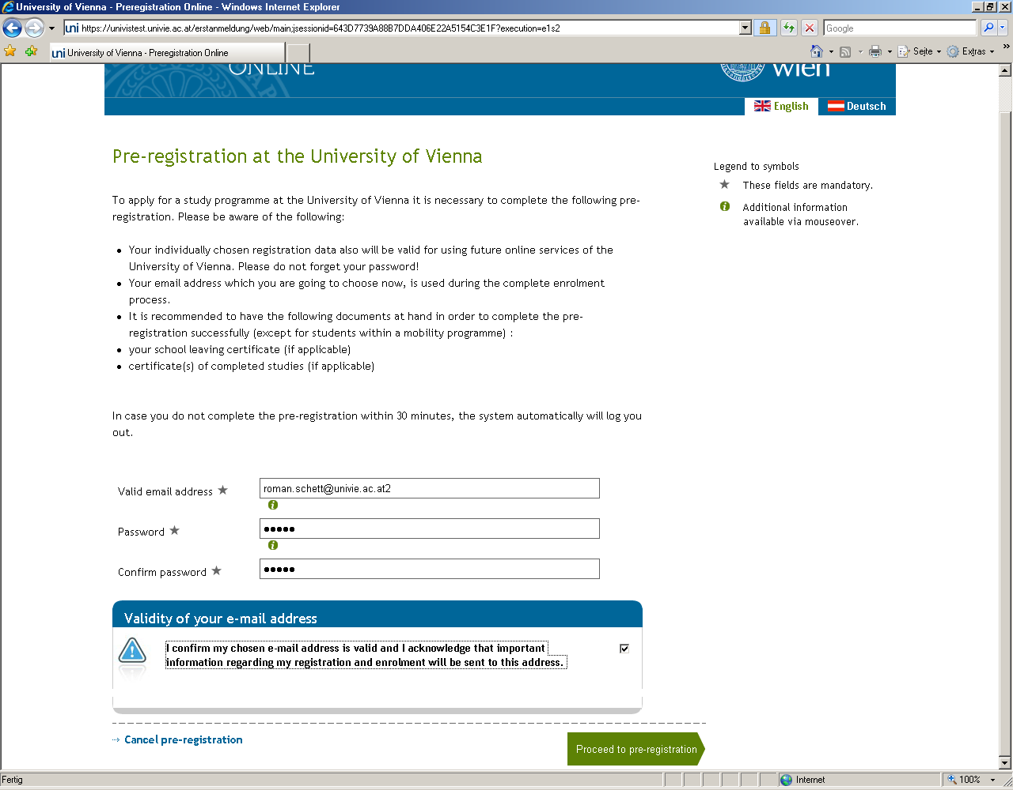
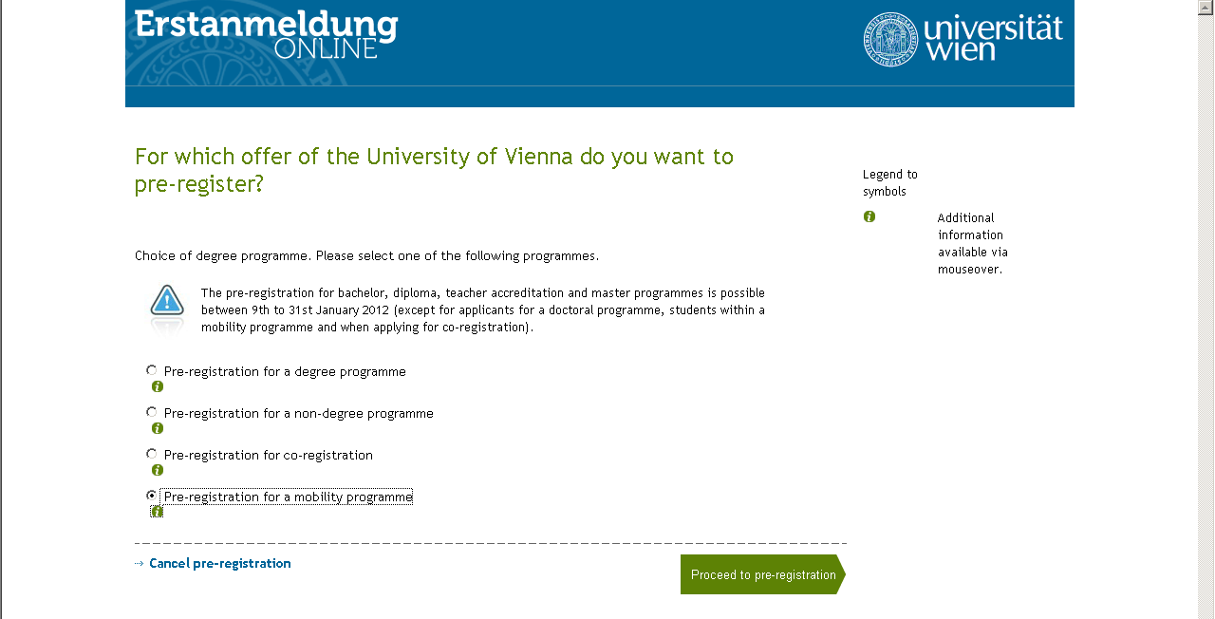
Please select the option „Pre-registration for a mobility programme“ (NOT „degree programme“).

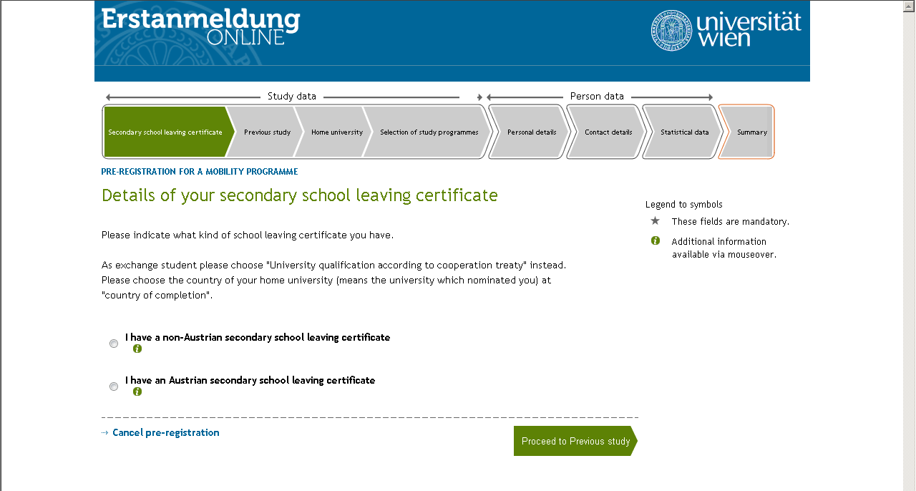
Please choose „University qualification according to cooperation treaty“ as type of secondary school leaving certificate. Due to your status as an exchange student no further details on your secondary school leaving certificate are required, please just choose the country of your home university that nominated you for the exchange as „Country of completion“.
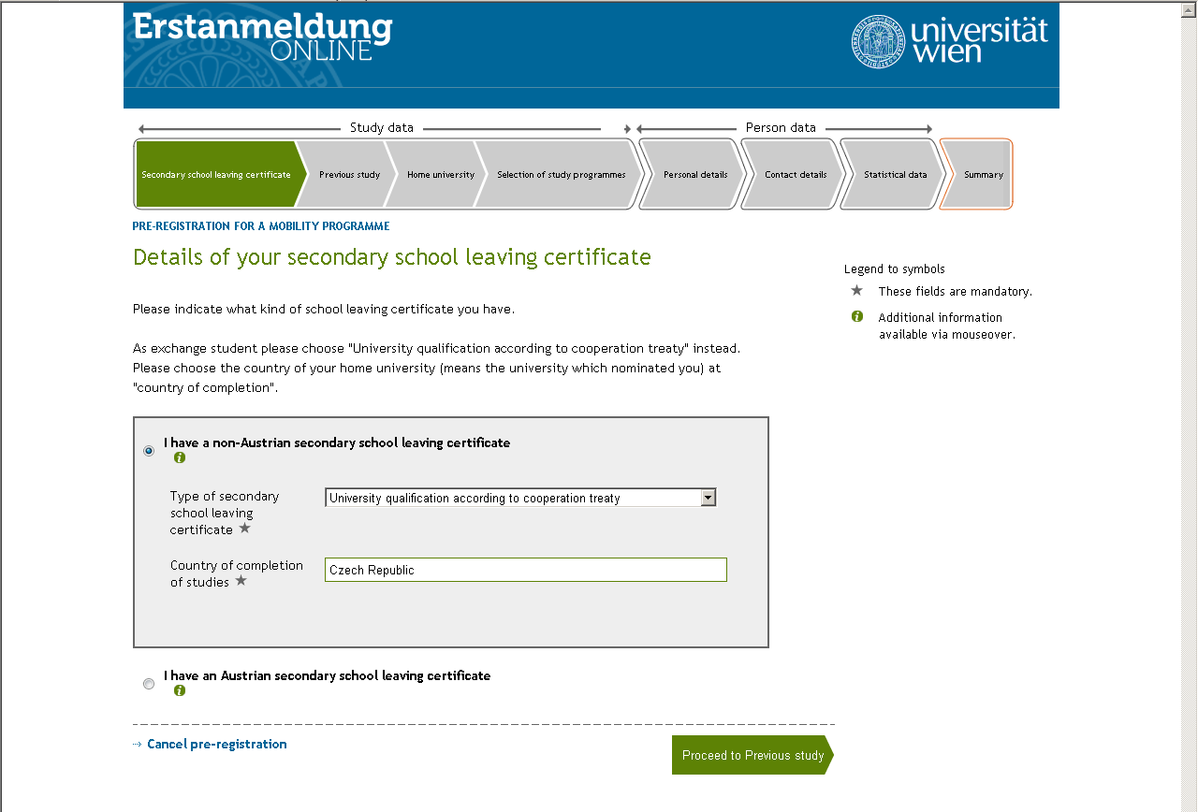
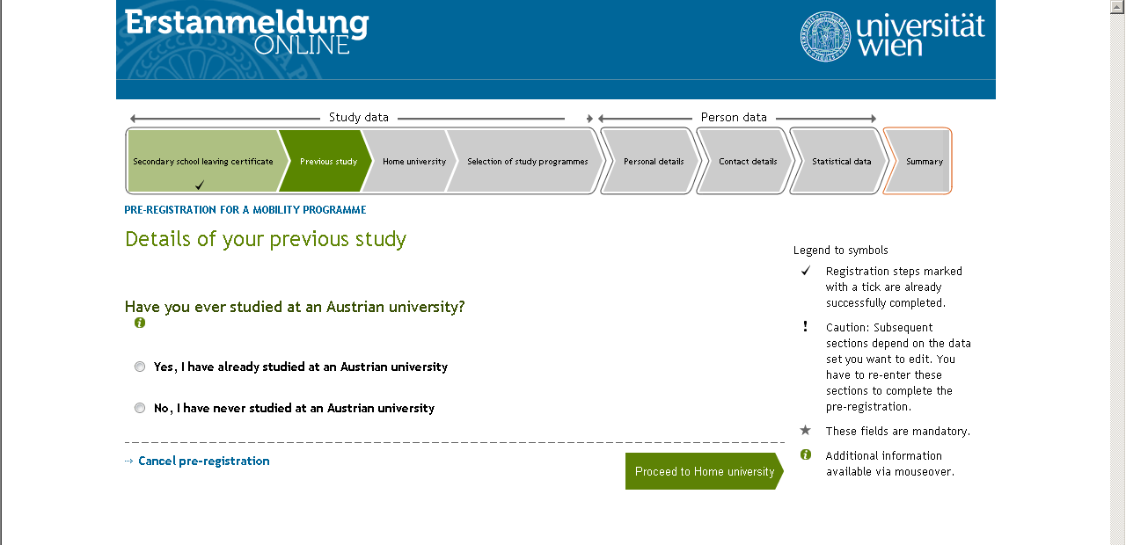
If you have never studied at an Austrian university before, please click on this option and then on „Proceed to home university“
Now we ask for some information on your study at your home university.
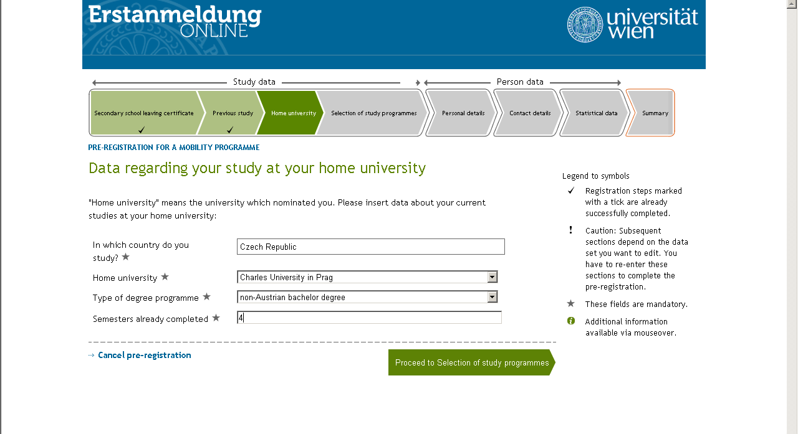

Since as an exchange student you can complete the pre-registration all year round, a wrong beginn semester may be mentioned in the section „Selection of study programme“. In this case, please inform us about the matter by e-mail (erasmus.international@univie.ac.at) after completing the pre-registration for manual modification.
Furthermore, you are now requested to select the study programme that you would like to enrol in at the University of Vienna.
PLEASE NOTE: If your study program does not appear, please complete the pre-registration by choosing any of the available programmes and inform us about this afterwards.
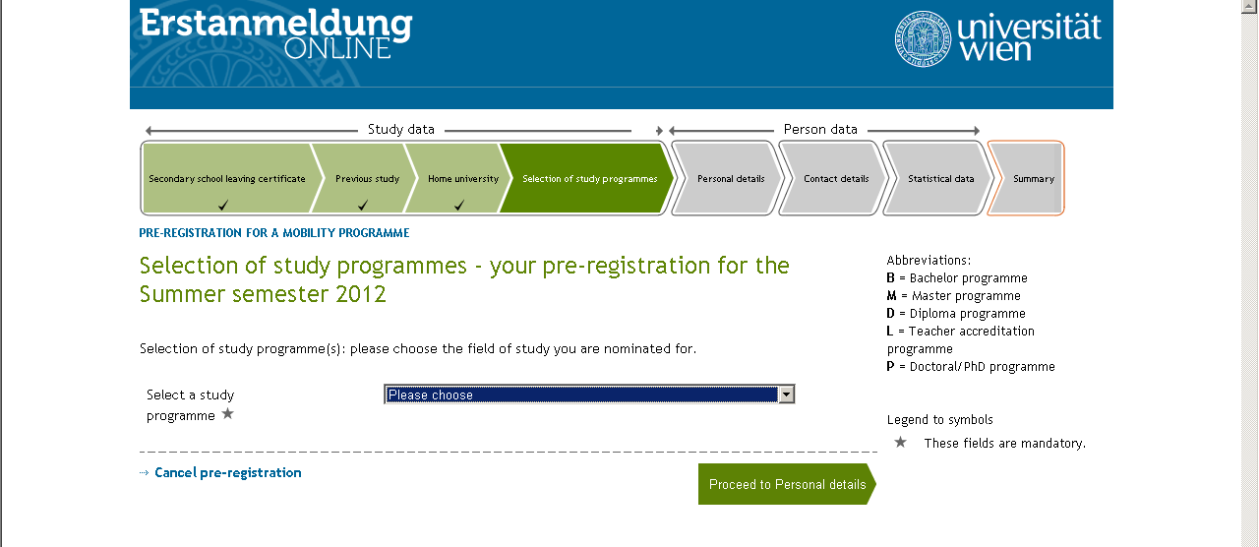

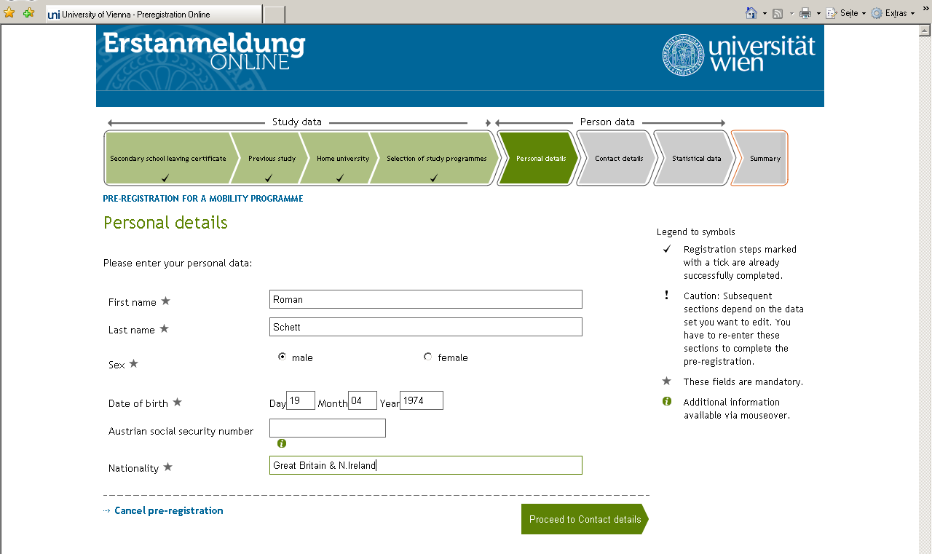
You can leave this field empty, unless you have an Austrian social security number.
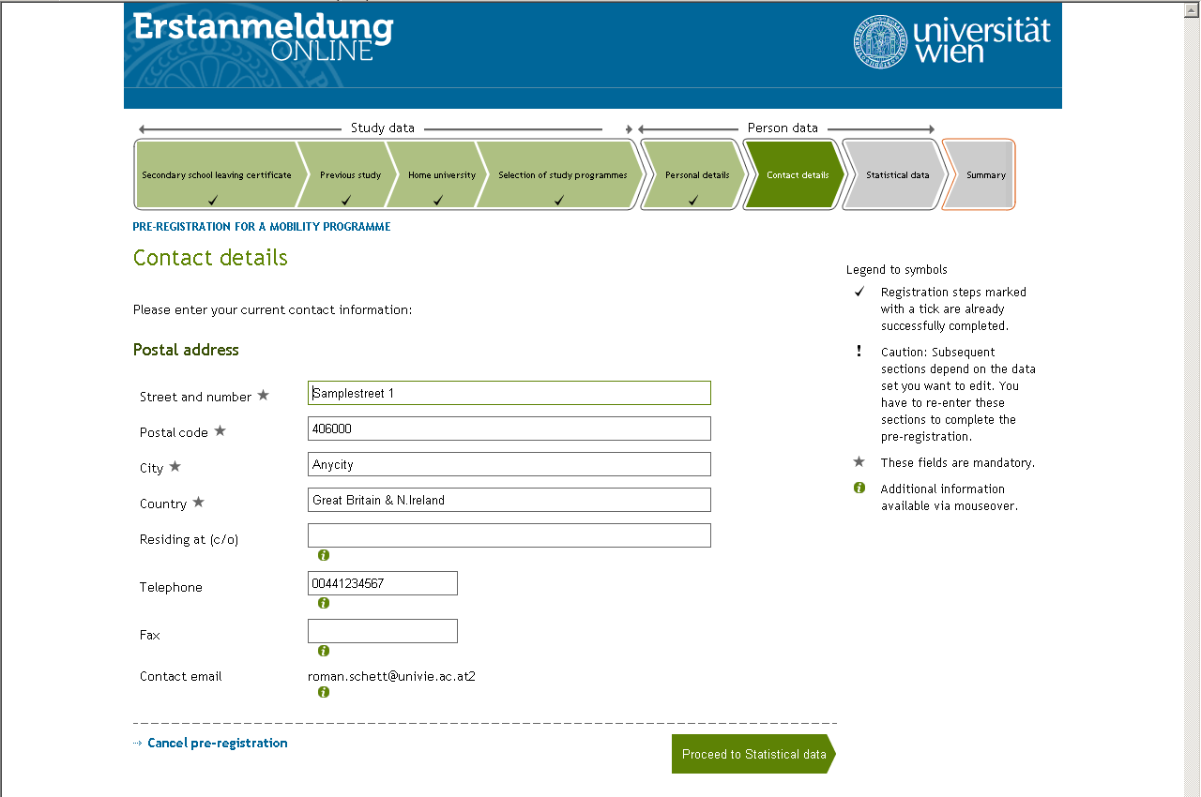
If possible, please also mention a phone number so that we can reach you in urgent matters as quickly as possible.
A couple of questions for the statistics:
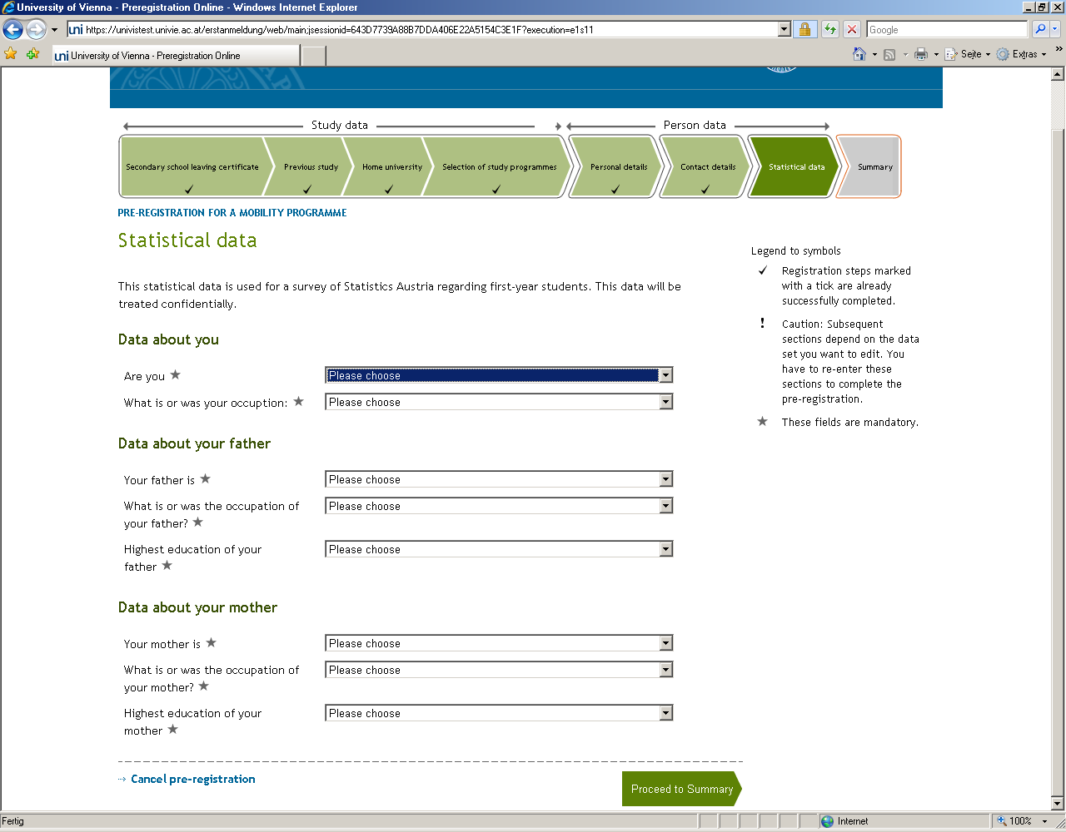

In the summary you have the possibility to edit your data, where necessary, once more before completing the online pre-registration and also to upload your „Joint Study Certificate“ in the bottom section of the page, in case it is already available but not sent to us yet.
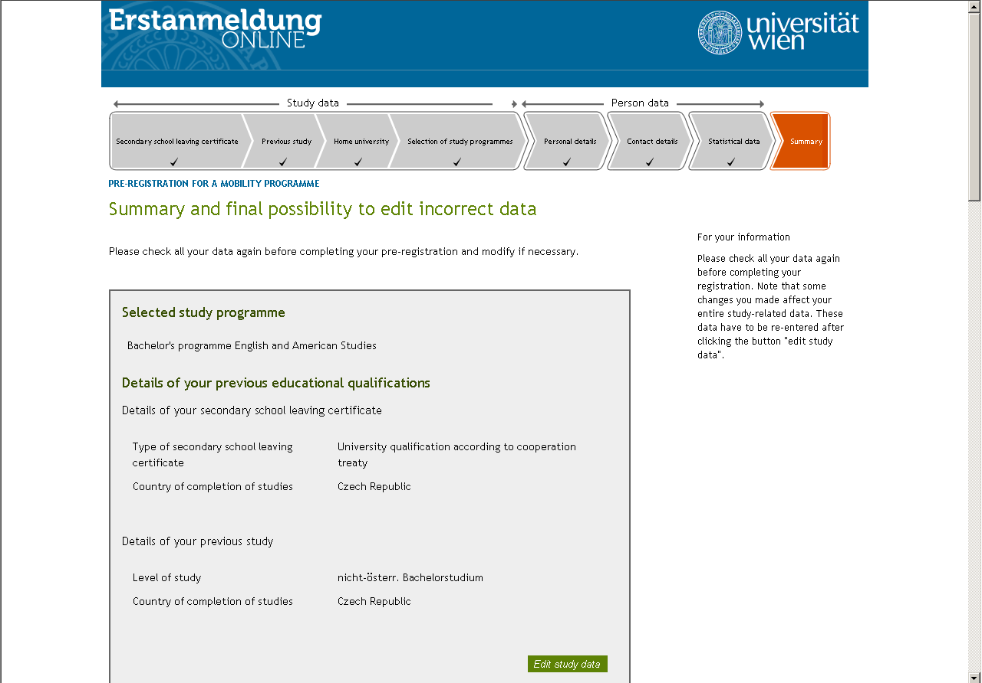

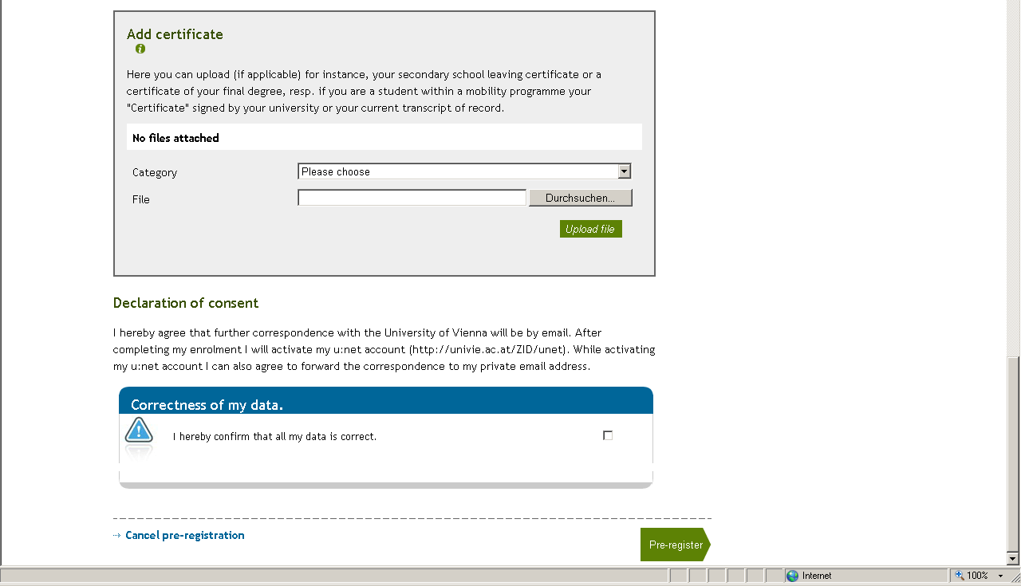

Congratulations on completing the online pre-registration as an exchange student at the University of Vienna successfully!
You will now receive an automatically generated e-mail with the PDF mentioned to the aforementioned e-mail address. (If you don’t receive this e-mail, please let us know. For exchange students it is not necessary to sign the summary nor to send it to us as an application form for admission, as opposed to what is mentioned in the PDF.)
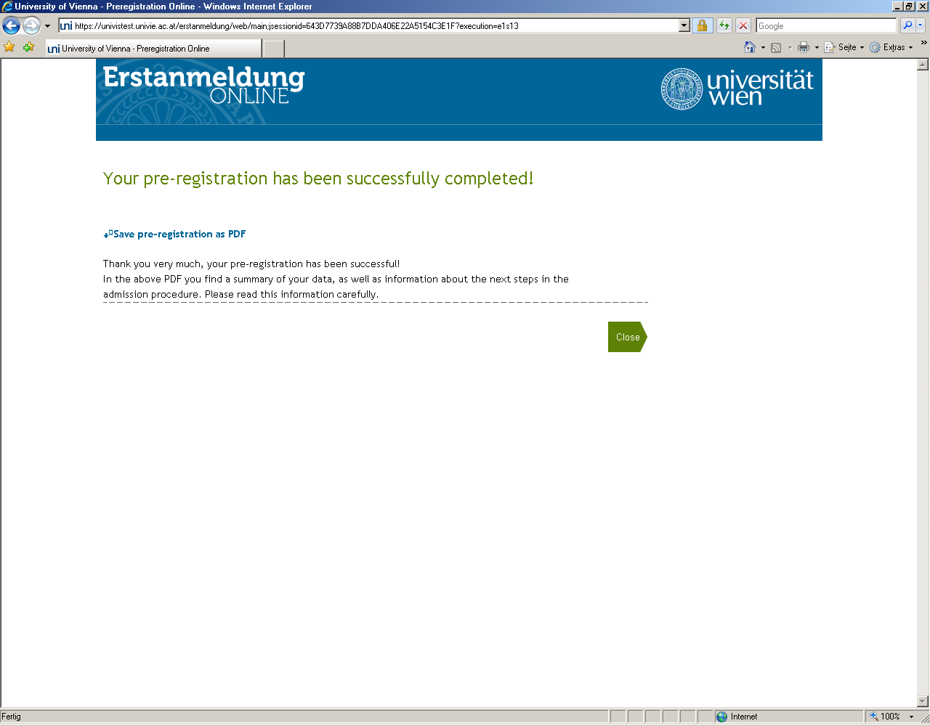

For further information related to Erasmus International students, please take a look at our website:
http://international.univie.ac.at/en/home/
( Incoming Students -> Erasmus International Mobility)
We will now prepare your enrolment and at the beginning of August (winter semester) or beginning of February (summer semester), you will receive an e-mail including your student ID number as well as further information.
Best wishes,
Nina Thiel
at the Student Mobility Office of the University of Vienna

